Scheme of Delegation

Published Date: November 2018

Next Review Date: November 2019

Author: Adam Dale (CEO)

Responsibility for Review: Leger Education Trust Board
Version 2 10/12/2018
CONTENTS

1. | Introduction | 3
2. | Trust Structures | 7
3. | Trust Members | 8
4. | Trustees | 9
5. | Academy Local Governing Boards | 11
6. | Role of Headteachers/Head of School | 13
7. | Role of Headteacher’s Board | 14
8. | Central Services | 15
9. | Model of Delegation | 16
10. | Summary of Delegation | 17
11. | Scheme of Delegation | 20
12. | Financial Delegated Authority | 28
Appendix 1. | Terms of Reference & Code of Conduct | 29

Introduction

  - Purpose

The purpose of Leger Education Trust’s Scheme of Delegation is to provide a clear framework for governance functions. The document will be reviewed and amended annually by the Trust’s Board. It will also be published on the Trust’s website.

As a charity and company limited by guarantee, (“the Trust”) is governed by a Trust Board (the “Trustees”) who are responsible for the management and administration of the Trust and the Academies within the Trust (“the Academies”).

The Trustees are accountable to external government agencies including the Charity Commission and the Department for Education (including any successor bodies) for the quality of the education provided by the Trust and they are required to have systems in place through which they can assure quality, safety and good practice.

This document explains the ways in which the Trustees fulfil their responsibilities for the leadership and management of the schools and academies, detailing the delegated roles and responsibilities of the Trustees and their committees, Local Governing Boards, the Chief Executive Officer, Headteachers/Principals, and the Executive Leadership Group of the Trust.

Any delegation made is subject to any conditions the Trustees may impose and may be reviewed and amended at any time in the best interests of the Trust.

  - Leger Education Trust Vision

Our Vision
‘Truly great students in truly great schools’

Our Aims
Our Aims will provide the framework for growth over the next 3 years across all academies within the Trust. The aims are:
- To ensure high quality education for the Leger Education Trust community, where our provision, is or aspires to be, consistently good or better.
- To improve the achievement of ALL students across the Trust and ensure consistency across all academies, key stages and subject areas.
- To ensure the quality of teaching and the curriculum is inspirational and accelerates students learning and progress.
- To ensure that all students can access high quality education, personal character development opportunities and skills for their next steps.
- To ensure consistent high quality practice across the Trust, whilst responding to the changing educational landscape and applying it to LET’s context.

Our aims must be the foundation for school improvement. Rapid and sustained improvement occurs through the dedication and hard work of all stakeholders and a complete and relentless pursuit of excellence. Our journey within Leger Education Trust will be a real challenge and will require honesty, resilience, collaboration and determination. However, this challenge is reflected back in our vision to develop ‘truly great students and truly great schools’.
Our Values
Our Values underpin all that we do towards achieving our vision and shape our core business which is the ‘business of learning’. Students energy, hope and expectations will ensure that they leave the Trust as young adults who are fully prepared to take their place in an ever changing world. This world requires young people who are well qualified, creative, resilient, entrepreneurial and of well-rounded character. Our Values are centred around four key themes:

- Community
- Pride
- Ambition
- Responsibility

These values will create a learning environment which will challenge our students to stretch themselves academically, be socially responsible and are ready to make a positive impact on and in our community.

We are striving to develop young people who achieve excellent outcomes (currency) at each of the milestones, but do this in a positive, supportive and collaborative school culture. Uniquely, a key focus of the Trust will be on the character development of the young people ensuring they are well rounded individuals who are ready to take their place in the world. This character will shape their life chances, as well as enhancing their school life and the wider community. Truly great students are those where currency, culture and character are maximised.

Culture
Character

Currency

A Strategic Three Year Plan
Six Areas of Focus
The three year plan will focus on the six areas which will achieve our vision of ‘truly great students in truly great schools’.

High Quality Teaching & Learning
The quality of teaching and learning will always sit at the heart of the Trust. This is the fundamental process which changes lives of students within our community. Staff recruitment, development and training will focus on truly great teaching throughout every Academy.

Achievement
Achievement of all students in LET will be a key indicator of success. The progress across the age ranges within LET will be maximised by effective monitoring and intervention and robust academic transition processes. The Key Performance Indicators and termly progress meetings will ensure a laser sharp scrutiny of an academy’s performance.

Financial Strategy
LET will ensure clear and transparent systems for financial effectiveness and value for money. The role of LET is to make efficient use of economies of scale and central support services that maximise the education of every student. A sustainable financial plan will be in place to support all schools to be fully resourced, have contingency funds, and meet the future needs of a changing educational landscape.

High Quality Governance
The quality of Governance across LET will ensure that expectations and standards are of the highest order. All members of Governance at all levels will be clear about their responsibilities and have access to relevant training and information to support their defined roles. Clear schemes of delegation define these levels of Governance and allow clear distinction between the strategic and operational responsibilities.

Character Development
The development of Character will be a fundamental part of what the MAT does to develop young peoples’ preparedness for life beyond school. Each Academy will have a clear thread of character development which is rigorously monitored and recognised at all ages. The links with business and external organisations as well as CIAG will be crucial to this aspect as we ensure they have the wider skills to thrive.

Building Capacity
The focus on the recruitment, training and development of high quality staff will ensure outstanding provision for all students. The role of LET will be to ensure all the needs of all academies are met through a workforce which both challenges and supports. Key roles will initially meet the growing MAT’s needs and then, as these needs develop, succession plans will be in place. Targeted CPD at all levels will ensure a highly skilled, up to date workforce.

  - Leger Education Trust Scheme of Delegation

Leger Education Trust will be run by a Board of Trustees. These Trustees will be appointed by the Members of the Trust. The Trust delegations are based on a “full” model of delegation with earned autonomy based upon:

- Academic performance;
- Financial performance, and;
- Compliance within the regulatory framework that all academies must operate within

The Board of Trustees retains overall responsibility and ultimate decision-making authority for all the work of the Trust regardless of delegation outlined within this document; in line with the direct responsibility to the Members to ensure the Trust’s charitable objects are met and to the Secretary of State for Education as the Principal Regulator. Therefore, the Board of Directors is ultimately entitled to:

- Overrule a decision of an Academy Local Governing Body;
- Remove delegated powers from an Academy Local Governing Body, and;
- In the most serious of situations, replace or suspend an Academy Local Governing Body.

Although Leger Education Trust is based on a “full” model of delegation, Trustees will monitor the performance across all the Academies within the Trust. The policy sets out a number of ‘triggers’ which would result in the Trust CEO intervening and agreeing a plan of action to support the Academy going forward. These will be reported to Trustees at their Board meeting and therefore will be scrutinised termly as well as each academic year.

The level of intervention and support will be dependent on the need and requirement of the Academy to improve and will be agreed between the Trustees, CEO, and Academy Principal (unless this is not appropriate). Examples of performance indicators within the Performance Escalation and Intervention Policy include:

- Performance of school (outcomes);
- Leadership and Management quality;
- Quality of Teaching and Learning across school;
- Safeguarding – in general and as a result of a specific incident;
- Whistle-blowing, and;
- Financial impropriety.

  - Review and Phasing

Reviewing
To ensure this document is relevant and up to date, it refers to documents on the Trust’s website and other sources. This document, and associated documents, will be formally reviewed regularly by the Trust Board. The Board of Trustees commits to reviewing and developing the governance structures as well as considering local and national policy and statutory duty changes.

Any proposed changes to the Scheme of Delegation will firstly be considered by the Trust Members Board before consultation with the Trustees and, if appropriate, the Local Governing Bodies.

Phasing

Leger Education Trust acknowledges the need for phasing in respect of ensuring the MAT is financially sustainable and allows itself to build. The Trust will be a ‘small’ Trust from its creation with one secondary and three primary schools. In phase one the Trust’s CEO will be employed on a Full-time basis whilst retaining a role as Principal of Campsmount Academy. This approach allows the Trust to be financially viable whilst building capacity and succession planning at Campsmount.

Where a Headteacher within the Trust is also the CEO, as in the case at Campsmount, a number of principles will be followed by the Trustees:

- The CEO’s performance management will be completed by an external resource;
- The CEO will also be performance managed externally in respect of their role as a Headteacher;
- The CEO will not be appointed as a Trustee;
- Trustees will review and challenge to ensure consistency with the review of other schools by the CEO.

As the Trust grows, this approach will be reviewed to ensure the performance of all academies within the Trust are scrutinised on an equal level.

  - Legal Framework and Guidance

This document complies with current Department for Education (DfE) policy and reflects the obligations on the Trustees imposed under both company law and charity law and acknowledges the status of the Trust as a public body. It reflects current guidance including (but not limited to) the following:

- Academies Financial Handbook (DfE)
- Governance Handbook and Competency Framework (DfE)
- Keeping Children Safe in Education (DfE)
- Admissions Code (DfE)

- Trust Structures

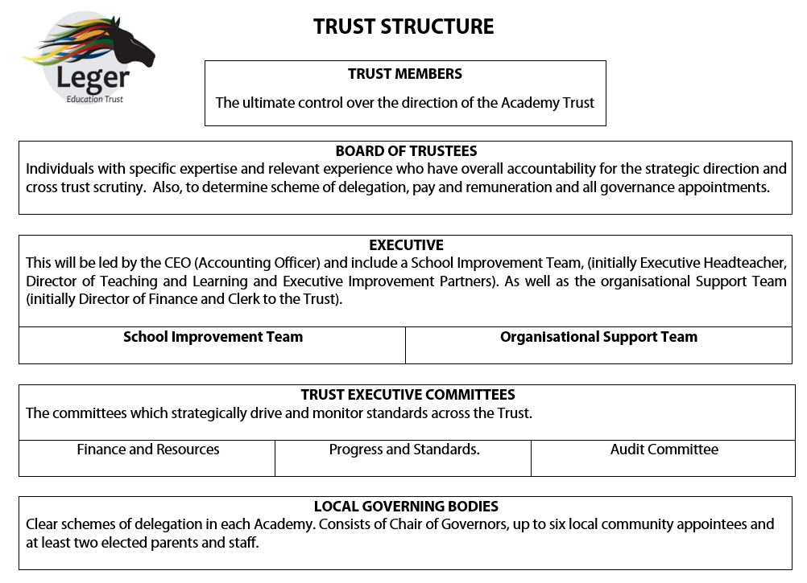

- Trust Members

3.1 Introduction

Members are akin to the shareholders of a company. They have ultimate control over the academy trust, with the ability to appoint trustees and the right to amend the trust’s articles of association.

The Members of the Trust are the subscribers to the Memorandum and Articles of Association and have responsibility for the overview of the governance of the Trust and the power to appoint and remove Trustees. They may also appoint the Chief Executive Officer as a Trustee. They must approve any changes to the Trust's Articles of Association. The Members may meet once a year. Quorum for Member committees is no less than three in attendance.

3.2 Members – Numbers and Appointments

There will be 5 Members during 2018/2019:
Mr David McEwan
Rev. Dr Richard James Walton
Mr Anton Maree
Mr Mathew Lynds
1 Vacancy

From the Articles of Association – the Members of the Trust:
- Are the signatories to the Memorandum.
- At any time the minimum number of Members shall not be less than three.
- An employee of the Academy Trust cannot be a Member of the Academy Trust.
- Each person entitled to appoint Members shall have the right from time to time by written notice delivered to the Office to remove any Member appointed by them and to appoint a replacement Member to fill a vacancy whether resulting from such removal or otherwise.
- Membership will terminate automatically if:
a. a Member (which is a corporate entity) ceases to exist and is not replaced by a successor institution;
b. a Member (which is an individual) dies or becomes incapable by reason of illness or injury of managing and administering his or her own affairs; or
c. a Member becomes insolvent or makes any arrangement or composition with that Member’s creditors generally.
- The Members may agree by passing a special resolution to appoint such additional Members as they think fit.
- The Members may agree by passing a special resolution to remove any Member(s). The Member whose proposed removal is the subject of the resolution shall not be entitled to vote on that resolution.
- In exercising their rights under these Articles and the Companies Act 2006, the Members shall not do anything or take any action which would cause the Academy Trust to contravene its Objects.
- Every person nominated to be a Member of the Academy Trust shall sign a written consent to become a Member and sign the register of Members on becoming a Member.
- Any Member may resign provided that after such resignation the number of Members is not less than three. A Member shall cease to be one immediately on the receipt by the Academy Trust of a notice in writing signed by the person or persons entitled to remove him under Articles 13 or 16 provided that no such notice shall take effect when the number of Members is less than three unless it contains or is accompanied by the appointment of a replacement Member.

  - Member Details
A full and current list of members can be found at www. legereducationtrust.com.

  - Reporting and Meeting
Members will meet once per year and will receive statutory and agreed reports from the Board of Trustees.

- Trustees

4.1 Introduction

Trustees are responsible for the same three core governance functions performed by Governing Boards in a maintained school:

- Ensuring clarity of vision, ethos and strategic direction;
- Holding executive leaders to account for the educational performance of the organisation and its pupils, and the performance management of staff; and
- Overseeing the financial performance of the organisation and making sure its money is well spent.

As charity trustees, they must also ensure that compliance with charity law requirements. Academy trusts are charitable companies, Trustees are company directors and therefore must comply with company law requirements. Duties are largely the same as those of a governor of a maintained school, such as regularly attending meetings, managing conflicts of interest, seeking advice from the academy’s leadership team and ensuring the academy has appropriate procedures in place for reporting financial information.

The Board of Trustees is the main Governing Board for Leger Education Trust and is accountable for the actions of all elements of the Trust including each school's performance, strategic direction, clarity of vision and financial probity. The Board will, however, work in partnership with its family of Academies.

  - Trustee Details
There will be 9 Trustees during 2018/2019:
Mr David McEwan
Rev Mark Wigglesworth
Mrs Babs Lynds
Mrs Bridget Gill
Mr Chris Knight
Mr Martin Drake
Mr Tony Mulvey
Mr Phil Crawley
Mrs Tracy Millard

Details of all Trustees can be found on www.legereducationtrust.com.

  - From the Article of Association – The Trustees – Number

There will be at least 9 Trustees.
- The number of Trustees shall be not less than three but (unless otherwise determined by ordinary resolution) shall not be subject to any maximum.
- The Academy Trust shall have the following Trustees:
a. at least 9 Trustees, appointed;
b. a minimum of 2 Parent Trustees elected or appointed under Articles 53-56B in the event that no Local Governing Bodies are established under Article 100a or if no provision is made for at least 2 Parent Local Governors on each established Local Governing Body pursuant to Article 101A.
- The Academy Trust may also have any Co-opted Trustee appointed under Article 58.
- The first Trustees shall be those persons named in the statement delivered pursuant to sections 9 and 12 of the Companies Act 2006.
- Future Trustees shall be appointed or elected, as the case may be, under these Articles. Where it is not possible for such a Trustee to be appointed or elected due to the fact that an Academy has not yet been established, then the relevant Article or part thereof shall not apply.

APPOINTMENT OF TRUSTEES

The Members may appoint by ordinary resolution at least 9 Trustees.
The total number of Trustees including the Chief Executive Officer if they so choose to act as Trustee under Article 57 who are employees of the Academy Trust shall not exceed one third of the total number of Trustees.
Trustees will be appointed by the Members. Where possible, appointments will be officially discussed and agreed at the annual Leger Education Trust Members meeting. Where timelines dictate a decision to be made outside of this meeting, an extra-ordinary Members meeting will be called to discuss and agree the appointment of Trustees.

  - Reporting and Meeting
The Board of Trustees will meet three times per year and will receive statutory and agreed reports from:

- Trust Committees:
  - Finance Committee
  - Audit Committee
  - Progress and Standards
- Local Governing Boards.
- Executive Leadership Team including the CEO and the DoF.

4.5 Functions of Committees

Progress and Standards: | - to scrutinise the standards and progress of all groups of pupils within the Trust and call the Executive to account as appropriate  - to monitor and scrutinise any Trust wide initiatives relating to standards and progress  - to ensure that LGBs are scrutinising appropriately standards and progress within their Academy and to call them to account for their actions  - to take a detailed view of standards and progress within academies where this is not delegated to the individual LGB  - to ensure all safeguarding is effective across the Trust
Finance and Resources | - to ensure the appropriate and effective use of Trust funds and to call the Executive and LGBs to account  - to ensure appropriate financial procedures and controls are in place  - to approve and monitor central funding expenditure and proposals  - to approve the proposed budget of individual Academies  - to oversee the capital programme and funding for the Trust  - to provide detailed scrutiny and oversight of the budget of Academies where this function is not delegated to the individual LGB  - to approve and monitor key HR policies and statistics across the Trust  - to review any exception H&S reporting as per H&S audit schedule  - to regularly review the Strategic Risk Register and implement actions as necessary
Audit | - to ensure probity in the financial decision making and procedures of the Trust  - to commission and receive internal and external reports and ensure the recommendations are enacted  - to call the Executive and Finance and Resources Committee to account for their decisions and actions
Local  Governing  Bodies | Operating under individual schemes of delegation, reporting to other committees as required. The range of responsibilities include:  - Oversight of standards, progress and provision  - Staff recruitment

- Academy Local Governing Boards

  - Introduction

Governors in a Local Governing Board carry the three main core functions as details in the Department for Education’s Governance Handbook (same as those of a Trustee):

- Ensuring clarity of vision, ethos and strategic direction;
- Holding executive leaders to account for the educational performance of the organisation and its pupils, and the performance management of staff; and
- Overseeing the financial performance of the organisation and making sure its money is well spent.
The Local Governing Boards are sub committees to the Board of Trustees. The delegation covers procedural and statutory powers for the operational life of each academy. It plays a key role in the life of each Academy and has responsibility, working with the Senior Leadership Team to improve every aspect of the Academy.

Each Academy will have a Local Governing Board (LGB) with at least two committees; Standards and Outcomes and Finance and Resources. All Academies LGBs will have at least 9 governors. Where Academies join the Trust, every effort will be made to either increase or reduce the LGB to the required number of 9 in a timely period. Typically, LGBs carry out the same functions regardless of their level of delegation and focus on the day to day running of the academy, carrying out the Trust's vision, policies and priorities, supporting and holding the academy leadership to account.

The structure of the membership should comprise of:

- Chair (Trust appointed)
- Headteacher/Head of School (Trust appointed)
- 5 Governors (Trust appointed)
- 2 Parent Governors
- 2 Staff Governors

  - Governor Terms of Reference/Code of Conduct

The Trust Terms of Reference are included in Appendix 1 and also include the Governors Code of Conduct.

  - Governor Details

The Governor details can be found on the individual school websites below:
www.campsmount.com
www.askernlittlemoor.co.uk
www.mossroad.doncaster.sch.uk
www.askernspa.doncaster.sch.uk

  - Reporting and Meeting

Local Governing Boards will meet three times per year and will receive statutory and agreed reports from:

- School/Academy Headteachers
- Finance and Resources Committee (where this meets as a separate committee)
- Standards and Outcomes Committee

- Role of Head Teachers/Head of School

Headteachers/Head of Schools are responsible for the leadership and management of their respective Academies. They report directly to their LGB and are accountable to their LGB and the CEO and Board of Trustees. They also have a responsibility to all other schools in the Trust and should be supportive of each other, ensuring the overall aims and objectives of the Trust are met.

They are responsible for the following to the extent that the responsibilities are matched in the Trust Scheme of Delegation:

- Implementing agreed policies and procedures, approved by the LGB and the Trust
- Ensuring the school is legally compliant on all levels; HR, Site, Premises, GDPR, website, Health and Safety
- Advising and playing a key role supporting the LGB, CEO and Trust with the strategic development of the Trust and school; strategic planning and quality assurance.
- Working with the CEO to set appropriate targets for all students, ensuring they are reported to LGBs and the Trust
- Evaluating the standards of teaching and learning in the school and ensuring that proper standards of professional performance are established and maintained
- Maintaining good behaviour and strong discipline including student exclusion and suspension from school based on the Trust's framework
- Ensuring a broad and balanced curriculum is implemented in their school and supports high levels of achievement
- Ensuring the Register of students' admission to school and the Register of student attendance are kept up to date
- Deploying effectively, leading and managing all teaching and non-teaching staff in the school
- Appointing and dismissing staff based on the scheme of delegation
- Maintaining a single central record and ensuring a regular documented review by the designated member of the LGB
- Maintaining whole staff training records especially in relation to Child Protection, Safeguarding and Safer Recruitment
- Ensuing sickness absence levels are monitored
- Advising on staff requirements, reviewing the staffing complement yearly based on the school's budget, recommending changes to the LGB before approval by the Trust Board
- Ensuring compliance with Safer Recruitment requirements and ensuring all identify documents and qualifications are verified and that DBS processes are followed
- Ensuring that GDPR is fully implemented and that data protection and Freedom of Information requests received are identified and actioned
- Ensuring all school financial information and information on organisation, achievement is current and on the website
- Implementing the Trust's Health and Safety regulations are applied appropriately
- Monitor the Trust's Educational Visits Policy and report to LGB on identified risks

7. Role of Head Teacher’s Board

All Academy Heads will meet at least once each half term as a board to discuss operational aspects of the Trust including pupil progress, attendance, staffing and curriculum development. Initially there will be one board but the expectation is that as the Trust grows there may be separate Primary and Secondary boards to support the differing needs and priorities of each phase.

The Head Teacher’s Board will act as a collective group in all aspects of activity and delivery where decision-making at Trust-level has an impact on all academies/schools.

The Head Teacher’s Board is included in the Decision-Making Matrix in Section 11 to ensure they have a clear role in the management of the Trust. Their main role is to consult with, and support, in all aspects of the Trust.

They are responsible for the following to the extent that the responsibilities are matched in the Trust Scheme of Delegation:

- Provide consultation on all aspects of Trust growth and vision setting
- Support the delivery of governance across the Trust including schedules of business and succession planning
- Provide consultation and support in all aspects of school improvement and education delivery – this is the key area in which the Head Teacher’s Board provide beneficial expertise for the performance of the Trust
- Provide consultation and support in relation to staffing structures and key roles across the Trust
- Reviewing staffing roles and efficiencies across the Trust
- Provide consultation and support in relation to trust-wide policy making, financial processes and accounting
- Provide consultation and support in relation to trust-wide compliance ensuring that each academy can adhere to policies

- Central Services

Central Services (top slice)
Executive Leadership) | Finance and MIS System | Back Office | Legal & Professional | Public Relations
Governance | Performance Monitoring | Staff Development | Policies & Procedures
Examples of Centrally Procured Services (optional buy-in)
Human Resources & Payroll | Grounds maintenance | School catering | Health & Safety | Estates Register & Management
IT Capital | IT Support Services | Facilities Management | Reprographics | Cleaning
Examples of Individual Schools/Academies Procured Services (optional)
Classroom resources and equipment | Specialist Kit & Equipment | Teaching Staff Cover | Teaching Support Staff Cover | Specialist Professionals

- Model of Delegation

The Trust model of delegation is dependent on the categories set out below:

- Full Level of Delegation
If an academy is judged as Good or better by Ofsted it will have a high level of autonomy. The academy will retain the majority of its powers, other than those reserved for the Board of Trustees that are strategic in nature or cannot be legally delegated. The performance, capacity and financial security of each academy will be reviewed by the Board of Trustees on an annual basis to assess the continued appropriateness of this status.

Central functions will be provided by the Trust, including finance, HR, governance support and compliance for all academies categorised at this level.

- Supported Level of Delegation
If an academy is judged by Ofsted to be less than Good, or in financial difficulty, it will have its performance reviewed annually; this will determine the level of delegated power. The principle will be to ensure that appropriate support and challenge are provided by the Trust, ensuing there is a strong focus on improving educational provision and that the academy is judged Good or better as soon as possible.

Central functions will be provided by the Trust as above. In addition, the level of support required centrally from the Trust will be confirmed by the Board of Trustees to the LGB.

- Sponsored Level of Delegation
A Sponsored academy is one typically where a school is judged by Ofsted as being in special measures or having serious weaknesses based upon its academic standards. A Sponsored academy would have limited delegated powers. The LGB would be small and appointed by the Board of Trustees with the right expertise to bring the academy out of its category as soon as possible. The school would be supported by strong executive leadership across the Trust.

Central functions will be provided by the Trust as above. In addition, the level of support required centrally from the Trust will be confirmed by the Board of Trustees to the LGB.

Whilst the Trust Board has overarching legal responsibility for the performance of each academy, the Trustees will delegate the following responsibilities to each academy for LGBs to hold their academy to account. The delegated responsibilities will be retained provided that all decisions made at a local level adhere to the Trust's vision and ethos and there are no conflicts with the proper use of each academy's delegated resource.

- Summary of Delegation
Please see Section 11 for a full Decision Matrix which sets out the accountability, responsibility, and involvement
level of:
- Members
- Trustees
- CEO
- Trust Senior Leadership Team
- Local Governing Bodies
- Head Teacher’s Board
- Head/Principals
- LGBs and Committees
The below provides a summary of each level’s involvement in each aspect of Trust delivery and management.

Strategic Leadership and Quality

Members | Provided with annual information against all strategic leadership and quality deliverables. Will provide consultation on the review of the Chair of Trustees performance.
Trustees | Accountable for all aspects of Trust level strategic leadership and quality deliverables.
CEO | Responsible for the delivery of strategic leadership and quality deliverables and provide support at LGB level in respect of performance reviews.
Executive Leadership Group | Support and consult in areas of reporting and vision setting in respect of key priorities.
Local Governing Bodies | Responsible for the vision and strategy setting at academy level. Responsible for LGB-level performance reviews.
Headteacher’s Board | Act as a collaborative and collective body where decisions at Trust level have an impact on all academies within the Trust.
Headteachers/Head of School | Support and consult in areas of reporting and vision setting in respect of key priorities against individual academies.

Governance

Members | Accountable and responsible for the reviewing and agreeing of Articles of Association. Provided with annual information against all governance deliverables.
Trustees | Accountable and responsible for all aspects of Trust governance. Also accountable for ensuring academy-level governance is in place and adheres to national governance frameworks.
CEO | Responsible for Trust-wide governance performance and structures and supports LGB-level governance performance and structures.
Executive Leadership Group | Consults and supports in areas of compliance and reporting for the Trust and individual academies.
Local Governing Bodies | Responsible for appointing LGB Chairs. Acts to support and consult in areas of governance at an LGB level.
Headteacher’s Board | Provides consultation and support in governance decision-making where there is an impact across all academies.
Headteachers/Head of School | Support and consult in areas affecting individual academies. Responsible for appointing LGB clerk and risk register for academy.

17

School Improvement and Educational Delivery

Members | Provided with annual information against all school improvement deliverables.
Trustees | Accountable for all aspects of school improvement and education delivery.
CEO | Responsible for most aspects of trust-wide educational delivery and school improvement. Acts to intervene, support and consult at academy level in accordance with the Performance Escalation and Intervention Policy.
Executive Leadership Group | Consult in some areas of key priority reporting across the Trust.
Local Governing Bodies | Consult in areas of school improvement and education delivery at an academy level.
Headteacher’s Board | Provides consultation and support in school improvement and education delivery decision-making and activity where there is an impact across all academies.
Headteachers/Head of School | Responsible for some aspects of school improvement and education delivery where it is specific to their academy. Provides support and consultation at a trust-wide level.

HR and Staffing

Members | Provided with annual information against all HR and staffing deliverables. Will appoint, suspend, and dismiss the Trust CEO.
Trustees | Accountable for all aspects of Trust HR and staffing.
CEO | Responsible for most aspects of Trust-wide HR and staffing and will support academy-level activity.
Executive Leadership Group | Provide support and consultation to many aspects of HR and staffing at both Trust and academy level.
Local Governing Bodies | Consult and support in areas of HR and staffing at an academy level. Responsible for the appointment, suspension, and dismissal of academy staff.
Headteacher’s Board | Provide some consultation and support where there is an academy-level impact from trust-wide decision making.
Headteachers/Head of School | Responsible for the appointment, suspension, and dismissal of senior leadership team members as well as the performance management of academy staff.

Finance, Policy and Estates

Members | Provided with annual information against all finance, policy and estates deliverables.
Trustees | Accountable for all aspects of finance, policy, and estates activity.
CEO | Accountable for all aspects of finance, policy, and estates activity through leadership of Trust staff.
Executive Leadership Group | Account for aspects of finance, policy, and estates reporting directly to CEO and Trustees.
Local Governing Bodies | Provide some support and consultation in aspects of finance, policy, and estates activity where there is an impact at academy level. Responsible for strategic policies at academy level.  The Trust shall be responsible for the setting and review from time to time of the Academy’s admissions policy provided that no change will be made to the admissions criteria without the written consent of the Trustees.
Headteacher’s Board | Provide some consultation and support where there is an academy-level impact from trust-wide decision making.
Headteachers/Head of School | Provide some support and consultation in aspects of finance, policy, and estates activity where there is an impact at academy level.

Legal and Compliance

Members | Provided with annual information against all legal and compliance deliverables. Will support the establishment and publishing of registers of interest.
Trustees | Accountable for all aspects of legal and compliance activity.
CEO | Responsible for policy development and adhering to legal documents.
Executive Leadership Group | Responsible for most aspects of compliance in relation to document management and record keeping.
Local Governing Bodies | Support the delivery of legal and compliance activity where tasks are specific to their academy.
Headteacher’s Board | Support many aspects of legal and compliance where activity at academy-level has a trust-wide impact.
Headteachers/Head of School | Provide some in many aspects of legal and compliance activity.

- Scheme of Delegation Matrix

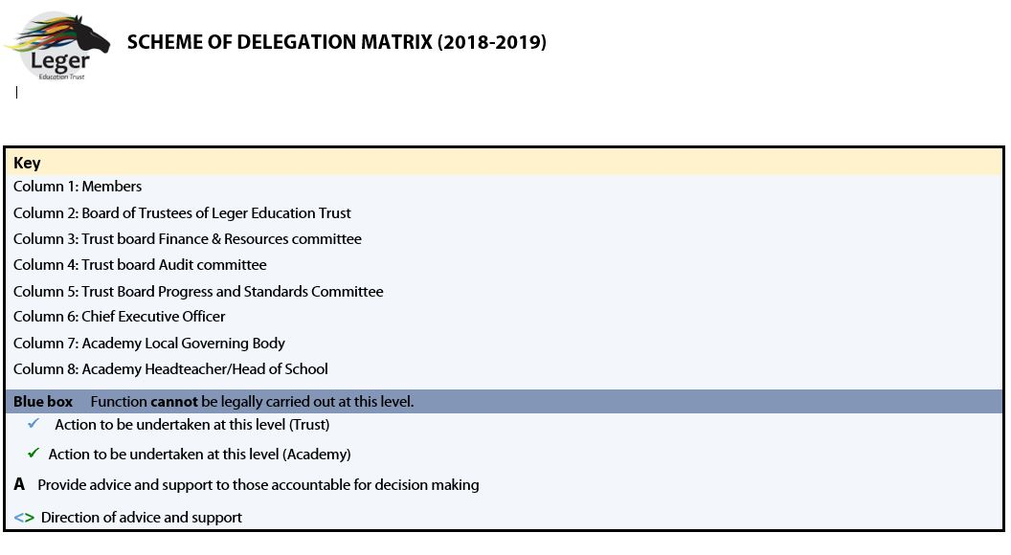
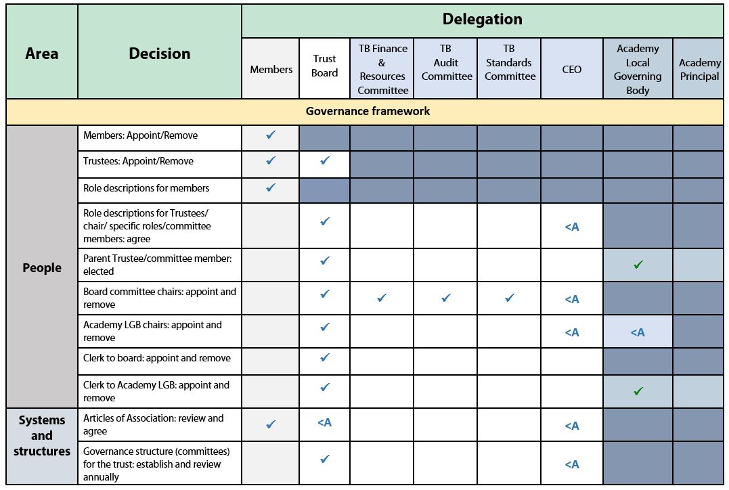
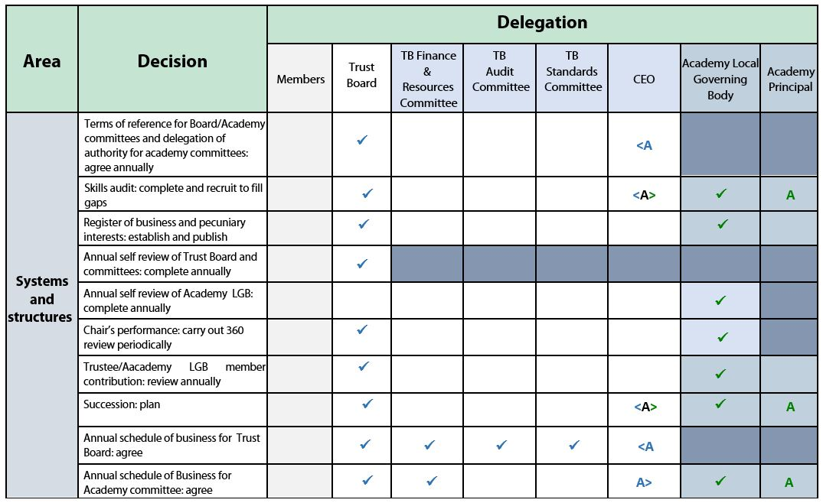
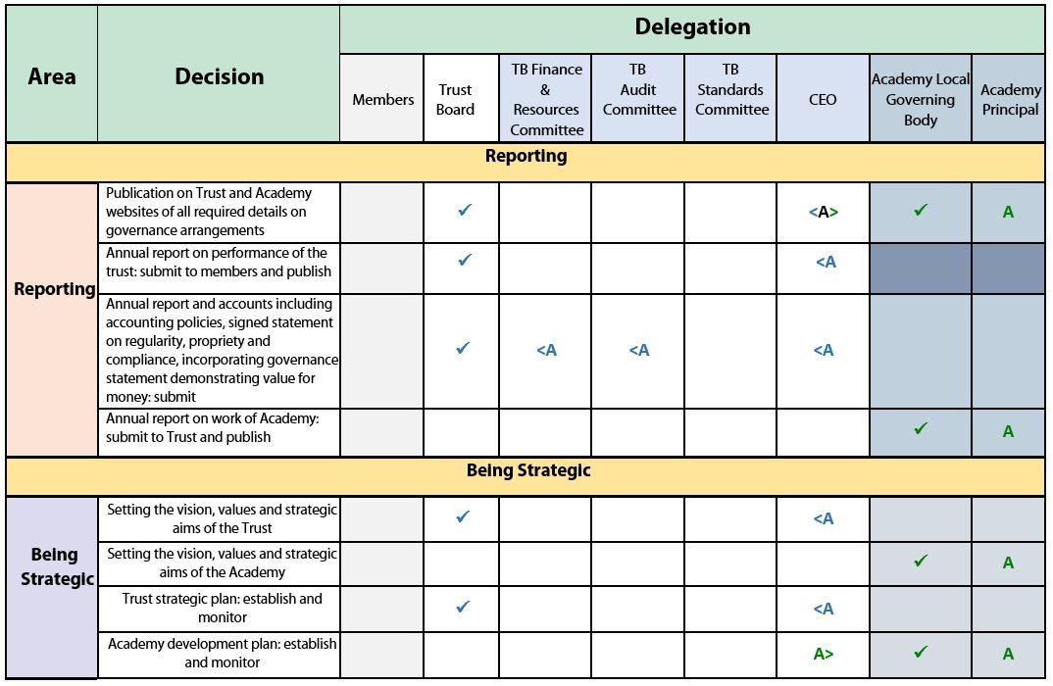

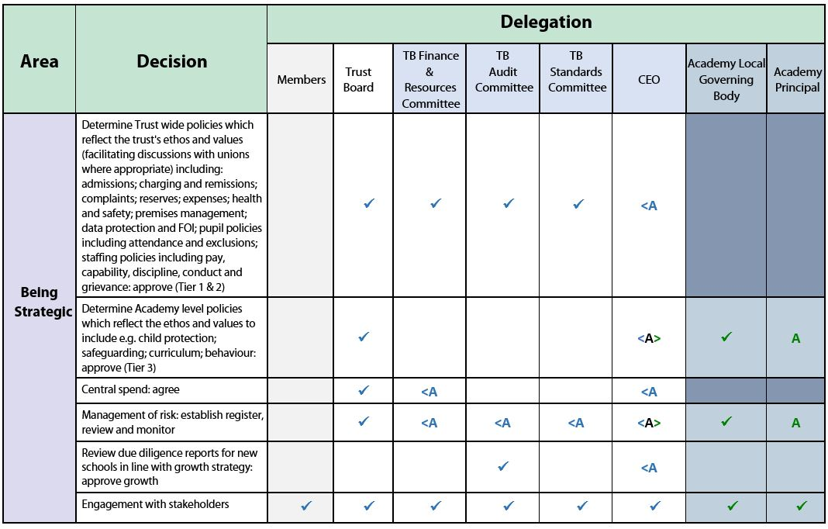

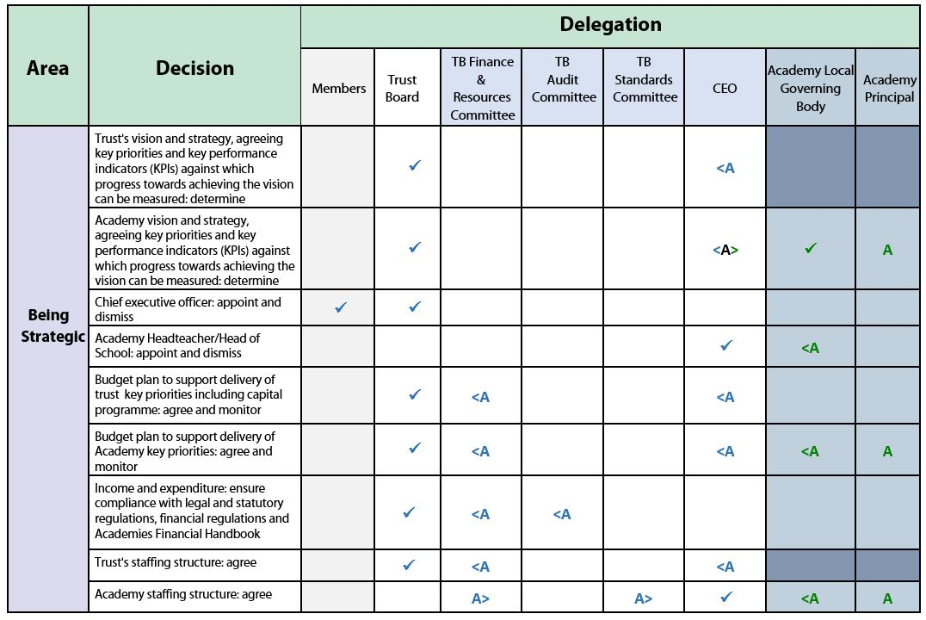

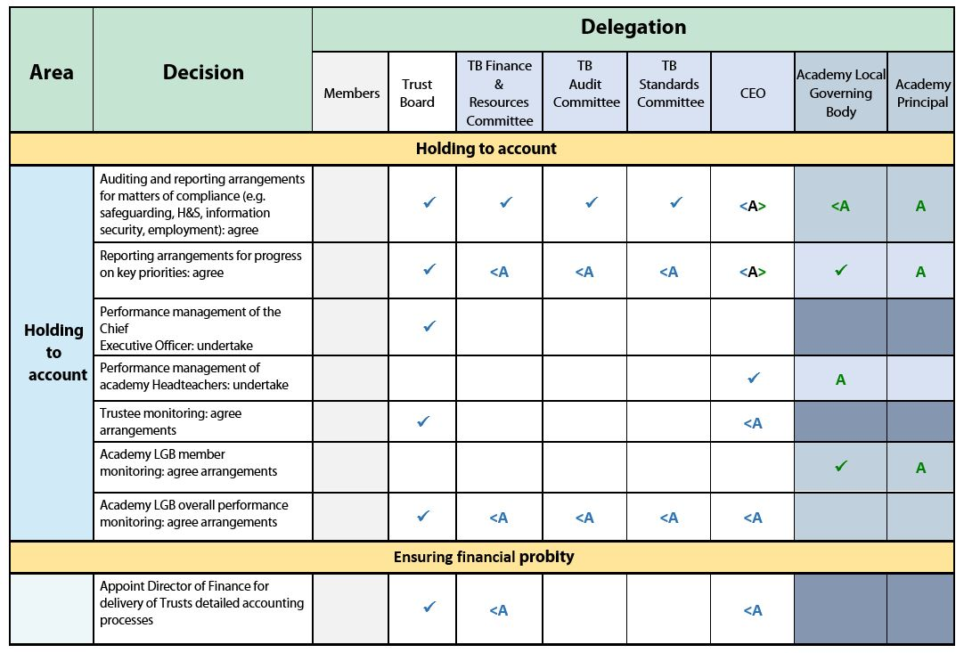

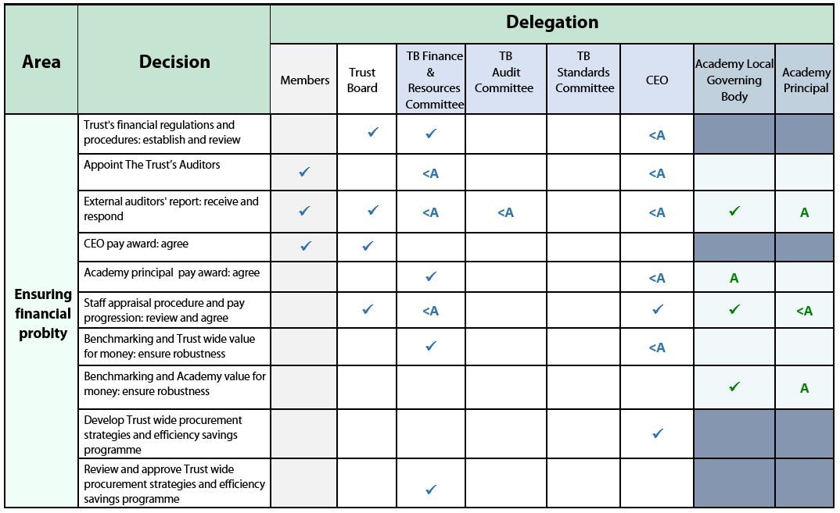

- Financial Delegated Authority

Delegation | Value | Delegated Authority
Ordering goods and services (raising requisitions) | Up to £1,000 | Budget holder plus school finance lead
 | £1,001 to £5,000 | As above plus Headteacher / Head of School
 | £5,001 to £30,000 | As above plus Trust DoF  - Minimum of 3 quotes
 | £30,001 to £100,000 | As above plus DoF and CEO – formal tendering process including advertising in OJEU if over threshold and Board Approval
 | Over £100,000 | As above plus Chair of the Board of Directors (or delegated board member). Formal tendering process including advertising in OJEU if over threshold
Authorisation of non-order invoices (excl. utilities and catering up to £1,000 | Up to £5,000 | Headteacher / Head of School & DoF
 | Over £5,000 | As above plus CEO
Operating leases / contracts (less than 1 year) | As per delegation limits above for ordering goods and services | As per delegated authority above for goods and services
Operating leases / contracts (over 1 year) | Over 1 year <£30,000 | Trust DoF plus CEO
 | > £30,000 | As above plus Board Approval
Finance leases | Any | All finance leases must be DoF & CEO as ESFA approval is required
BACs payments and other online bank transfers  (for invoice and pay runs) | Up to £10,000 | School finance lead
 | £10,000 - £30,000 | Headteacher / Head of School plus DoF
 | £30,001 to £100,000 | As above plus CEO
 | Over £100,000 | As above plus DoF
Cheque signatories | Up to £1,000 | 2 signatories from Headteacher / Head of School, Academy finance lead (and any other designated signatory personnel as noted on the bank mandate)
 | Over £1,000 | As above plus DoF
Signatories for EFA grant claims | Any | Signed hard copy document to be kept on file as required by claim form (Headteacher or delegated signatory)
Transfers with net nil impact on surplus / deficit position | Up to £30.000 | Academy finance lead in conjunction with the Headteacher / Head of School reported to the LGB Finance and Resources Committee and DoF
 | Over £30,000 | Full LGB / DoF / CEO
Individual BACs payments for deposits/payment on account/refunds | Up to £1,000 | School Finance Lead
 | £1,000 - £5,000 | School Finance Lead and Headteacher/Head of School
 | >£5,000 -  < £30,000 | School Finance Lead and Headteacher/Head of School plus Trust DoF
 | > £30,000 | School Finance Lead and Headteacher/Head of School plus Board Approval
Foreign Travel | Any | Board Approval
CEO / DoF Expenses | < £1,000 | DoF or CEO to sign off each other’s expense
 | >£1,000 | As above plus Board Approval

Appendix 1.
Terms of Reference & Code of Conduct

This document sets out both the terms of reference, and expectations of and commitment required from members of the Leger Education Trust Board and individual Local Governing Bodies. These will provide the basis to
- Enable the MAT / LGB to carry out its work within the Academy and the community
- Support its vision of ‘Truly great students in truly great schools’.

Strategic Functions:

The Leger Education Trust has established a commitment to truly great students in truly great schools. The Directors of the Trust have ultimate responsibility for the Academies, largely exercised by strategic planning, budget setting and monitoring of performance.
Within this commitment and bearing in mind the overall responsibility of the Trust, Littlemoor, Moss Road, Campsmount and Askern Spa have their own vision, values and objectives.

The Local Governing Body have delegated responsibilities for:

Strengthening the School’s strategic direction, by:
- Pursuing the vision, values, and objectives of the Schools
- Agreeing an appropriate School Improvement Plan with priorities and targets
- Meeting statutory duties

Ensuring accountability, by:
- Monitoring progress towards targets
- Contributing to the performance management of the Head of School
- Engaging with stakeholders
- Contributing to school self-evaluation

Ensuring financial probity, by:
- Adopting an annual financial budget
- Monitoring spending against the budget
- Ensuring value for money is obtained
- Ensuring risks to the organisation are managed

As individuals on Local Governing Body/ Trust Board we agree to the following:

Role & Responsibilities
- We understand the purpose of the LGB / MAT board and the roles of the CEO, Executive Headteacher and Head of Schools.
- We accept that we have no legal authority to act individually, except when the Local Governing Body/Trust board has given us delegated authority to do so, and therefore we will only speak on behalf of the Trust / Local Governing Body when we have been specifically authorised to do so.
- We accept collective responsibility for all decisions made by the boards or its delegated agents. This means that we will not speak against majority decisions outside meetings. This includes following and adhering to a social media policy.
- We have a duty to act fairly and without prejudice, and in so far as we have responsibility for staff, we will fulfil all that is expected of a good employer.
- We will encourage open government and will act appropriately.
- We will consider carefully how our decisions may affect the community and other schools.
- We will always be mindful of our responsibility to maintain and develop the ethos and reputation of our school. Our actions within the School and the local community will reflect this.
- In making or responding to criticism or complaints affecting the School we will follow the procedures established by the Trust /Local Governing Body
- We will actively support and challenge the CEO, Executive Headteacher and Head of School.

Commitment
- We acknowledge that accepting office as a governor involves the commitment of significant amounts of time and energy and as a result we will mutually support each other and support the Leadership of the Trust.
- We will each involve ourselves actively in the work of the Trust Board / Local Governing Body, and accept our fair share of responsibilities, including service on committees or working groups.
- We will make every effort to attend all meetings and where we cannot attend explain in advance why we are unable to.
- We will get to know the Schools well and respond to opportunities to involve ourselves in School activities.
- We will visit the Schools, with all visits to Schools arranged in advance with the staff and undertaken within the framework established by the Trust / Local Governing Body and agreed with the CEO, Executive Head / Head of School.
- We will consider seriously our individual and collective needs for training and development, and will undertake relevant training

Relationships
- We will strive to work as a team in which constructive working relationships are actively promoted.
- We will express views openly, courteously and respectfully in all our communications with other governors.
- We will support the Chair in their role of ensuring appropriate conduct both at meetings and at all times.
- We are prepared to answer queries from other governors in relation to delegated functions and take into account any concerns expressed, and we will acknowledge the time, effort and skills that have been committed to the delegated function by those involved.
- We will seek to develop effective working relationships with the CEO, Executive Head/ Heads of School, staff and parents, the local authority (when appropriate) and other relevant agencies and the community.

Confidentiality
- We will observe complete confidentiality when matters are deemed confidential or where they concern specific members of staff or pupils, both inside or outside school
- We will exercise the greatest prudence at all times when discussions regarding school business arise outside of meetings
- We will not reveal the details of any vote of the Boards.

Conflicts of interest
- We will record any pecuniary or other business interest (including those related to people we are connected with) that we have in connection with the business of the boards in a Declaration of Personal of Business Interests, and if any such conflicted matter arises in a meeting, we will offer to leave the meeting for the appropriate length of time.
- We will also declare any conflict of loyalty at the start of any meeting should the situation arise.
- We will act in the best interests of the trust as a whole and not as a representative of any group, even if elected to the governing body.

Breach of this code of conduct
- If we believe this code has been breached, we will raise this issue with the Chair and the Chair will investigate; the Trust /LGB will only use suspension/removal as a last resort after seeking to resolve any difficulties or disputes in more constructive ways.
- Should it be the Chair of the LGB that we believe has breached this code, the matter will be referred to the Trust Members.

The Seven Principles of Public Life
(The Seven Principles of Public Life are a useful summary of expectations. These were originally recommended by the Nolan Committee: The Committee on Standards in Public Life, established in 1994).

Selflessness - Holders of public office should act solely in terms of the public interest. They should not do so in order to gain financial or other material benefits for themselves, their family, or their friends.

Integrity - Holders of public office should not place themselves under any financial or other obligation to outside individuals or organisations that might seek to influence them in the performance of their official duties.

Objectivity - In carrying out public business, including making public appointments, awarding contracts, or recommending individuals for rewards and benefits, holders of public office should make choices on merit.

Accountability - Holders of public office are accountable for their decisions and actions to the public and must submit themselves to whatever scrutiny is appropriate to their office.

Openness - Holders of public office should be as open as possible about all the decisions and actions that they take. They should give reasons for their decisions and restrict information only when the wider public interest clearly demands.

Honesty - Holders of public office have a duty to declare any private interests relating to their public duties and to take steps to resolve any conflicts arising in a way that protects the public interest.

Leadership - Holders of public office should promote and support these principles by leadership and example.

All members of both Leger Education Trust and Local Governing Bodies MUST sign this Code of Conduct

Adopted by the Leger Education Trust: 6th December 2018

Due to be reviewed by: Annually

